**Date: 3/8/23**

**Teaching Week: Week 2**

**Team Name: Cheesecake**

**Team members present: All**

**Consultation Activities with the Client and Outcomes**

* Sent e-mail to Dr. Vikram Joshi to request a meeting to find out more about the project specifications

**Items discussed and worked on from the previous week**

*Including their current state (e.g., not started, in progress, completed, etc.) and team member allocation.*

| **Item** | **Current State** | **Team Member(s) Responsible** | **Notes** |
| --- | --- | --- | --- |
| Created whatsapp group | Completed | All |  |
| Choose project 6 | Completed | All |  |
| Scheduling meeting with client | In progress | Michael, All |  |
| Team charter | In progress | All |  |
|  |  |  |  |
|  |  |  |  |
|  |  |  |  |

**Issues That Arose**

**Actions Required**

* Align group members’ schedules and plan weekly internal meeting time

**Deliverables to be completed by the next week, including plan**

*Including team member allocation to tasks/deliverables*

| **Item** | **Due Date** | **Team Member(s) Responsible** | **Notes** |
| --- | --- | --- | --- |
| Align group members’ schedules and plan weekly internal meeting time | 7/8/23 | All | Whatsapp |
| Complete team charter | 18/8/23 | All |  |
|  |  |  |  |
|  |  |  |  |
|  |  |  |  |
|  |  |  |  |
|  |  |  |  |

**Other Comments**

**Signed and Accepted**

**Date: 7/8/23**

**Teaching Week: Week 3**

**Team Name: Cheesecake**

**Team members present: All**

**Consultation Activities with the Client and Outcomes**

* Awaiting response from client regarding meeting time

**Items discussed and worked on from the previous week**

*Including their current state (e.g., not started, in progress, completed, etc.) and team member allocation.*

| **Item** | **Current State** | **Team Member(s) Responsible** | **Notes** |
| --- | --- | --- | --- |
| Meeting time internal decided on Whatsapp | Completed | All | Fridays 16:00-18:00 on zoom |
| Scheduling meeting with client | In progress | Michael, All |  |
| Initial internal brainstorm on project brief | Completed | All |  |
| Team charter | In progress | All |  |
| Create team drive | Completed | Josefien |  |
|  |  |  |  |
|  |  |  |  |

**Issues That Arose**

**Actions Required**

**Deliverables to be completed by the next week, including plan**

*Including team member allocation to tasks/deliverables*

| **Item** | **Due Date** | **Team Member(s) Responsible** | **Notes** |
| --- | --- | --- | --- |
| Complete MOOC FHIR course | 27/10/23 by 3PM | All | Attempt to complete asap |
| Hand in team charter | 18/8//23 by 3PM | All |  |
|  |  |  |  |
|  |  |  |  |
|  |  |  |  |
|  |  |  |  |
|  |  |  |  |

**Other Comments**

Link to drive: <https://drive.google.com/drive/folders/1vCUVu4ztUxa4lqy4K8F0WqPGZnTDtNFO?usp=sharing>

Note about project deadlines

* 18/8/23 3pm: Team Charter
* 26/10/2023 4-6pm: In class presentation
* 06/11/2023 3pm: Project Due

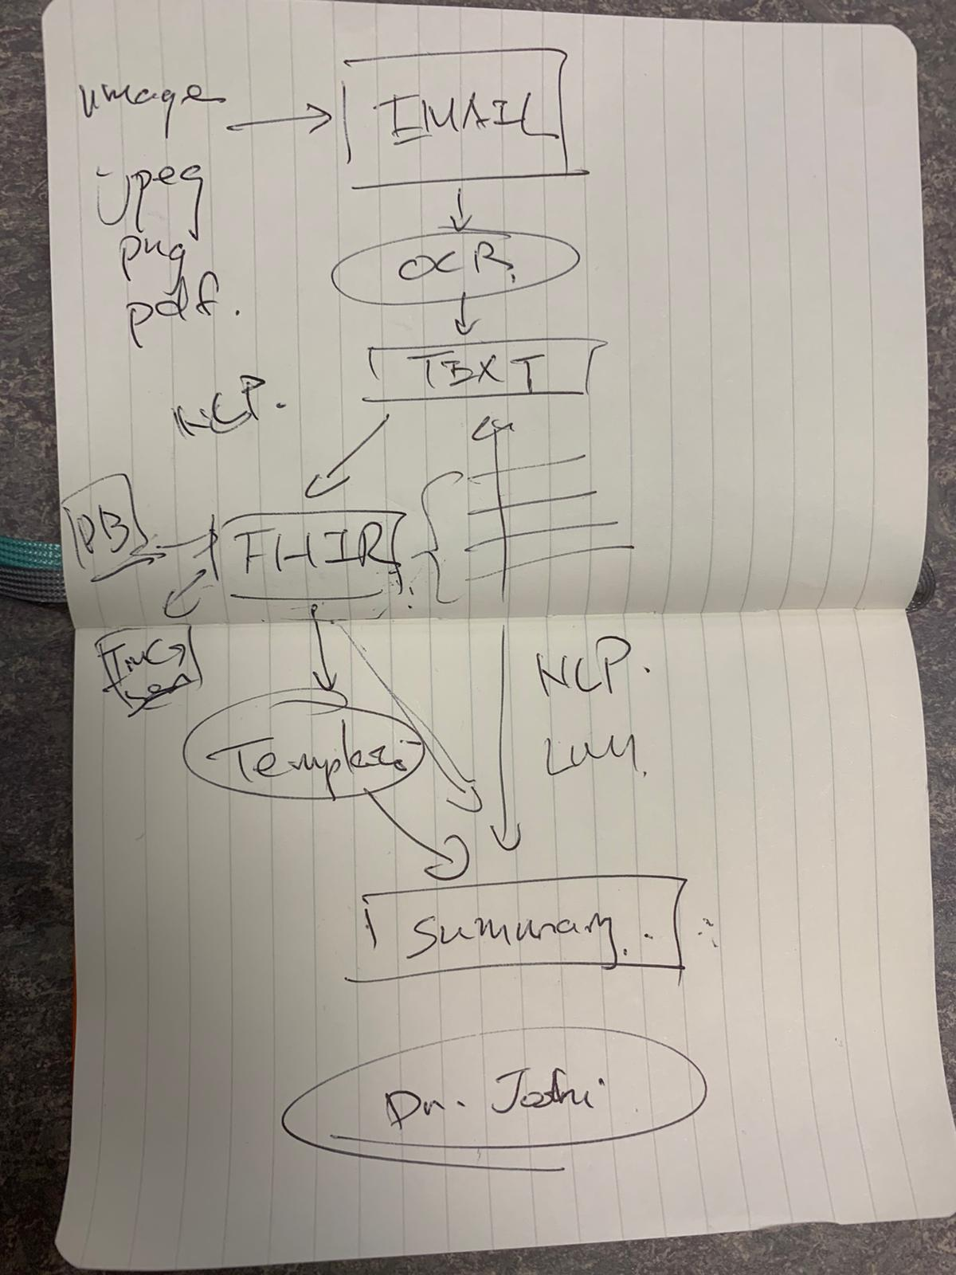

**Signed and Accepted**